Dear Colleagues and Friends,
we would like to invite you to the

10th International Conference on Management

Zero Waste Management and Circular Economy

ONLINE

to be held at the
Mendel University in Brno
10-11th June 2021
organized by

Mendel University in Brno, Czech Republic, Faculty of Business and Economics

in cooperation with

Częstochowa University of Technology, Poland, Faculty of Management
Slovak University of Agriculture in Nitra, Slovakia, Faculty of Economics and Management
Szent István University, Gödöllő, Faculty of Economics and Social Sciences
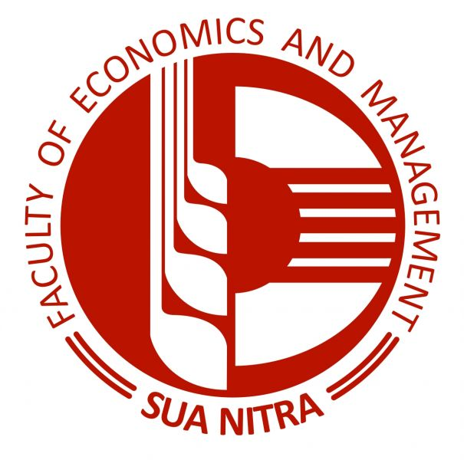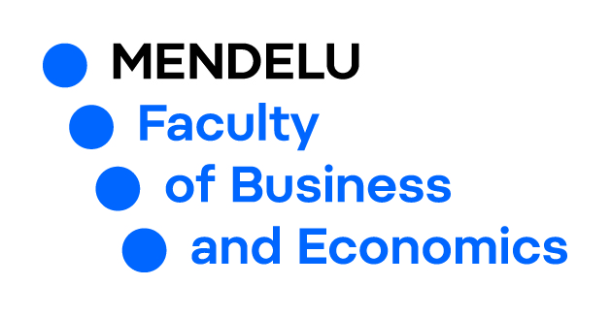
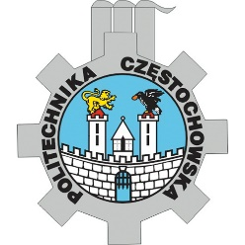

This is the 10th event of the International Conference on Management (ICoM) conference series which was started in 2011 with the idea to bring together scientists, researchers, PhD students and the representatives of the business sector to exchange and share their experiences and research results about contemporary management and social issues.

Nowadays, sustainability is a key question of our life, all over the world. Sustainability is related to the natural environment, economy and society. In the recent years, sustainable economy, sustainable society and sustainable development became one of the key management objectives and the subject of multidisciplinary scientific researches. That´s why the topic of the last year´s conference was focused on people, profit, planet concept. This year we would like to open the question of zero waste concept as a part of circular economy. The whole conference will be organized as a zero waste event. However, other topics will be also welcome. Due to the persistent situation with the COVID pandemic, the entire conference will take place in an online environment.

The aim of the conference is to provide opportunity for scientists and professionals from various areas of knowledge and disciplines to meet each other, to share their experiences, research results and theoretical studies and to build and strengthen international cooperation for improving the quality of scientific research. An additional goal of the conference is build a bridge between experienced researchers with the young researchers and PhD students to start new relationships and research networks to work together the next generations.

CONFERENCE TOPICS / SESSIONS:
- Social reponsibility and sustainability
  - Corporate social responsibility; Zero waste management; Sustainability; University social responsibility and sustainability
- Business strategies and management
  - Management and evolution process of SMEs; Entrepreneurship, new venture creation, startups; Human resource management and leadership; Knowledge management and innovation management
- New trends in marketing and supply chain management
  - B2B marketing and B2C marketing; Digital marketing; Brand marketing; International marketing, Social media marketing
- Financial management
  - Accounting; finance; taxes, investment management
- Regional development management
  - Regional policies, sustainable development, public administration management; rural policy management
- Tourism management
  - Sustainable tourism; story telling in toursim; innovation in tourism; media and technology in tourism; destination management and marketing

SPECIAL TOPICS / SESSIONS:
- CSR and circular economy in business praxis (special session for business people, social enterprises and NGOs)
  - in English
  - in Czech

The official language of the Conference is English with no translation. All the information about the conference can be found at the website of the conference: https://icom.pef.mendelu.cz/

REGISTRATION
The registration form has to be done via the following link: ICOM Registration form.
Or you can use the QR code:

In case of full participation at the conference, send your extended abstract to icom@pef.mendelu.cz . Only abstracts filled in the template (see Download session) will be accepted.

ABSTRACT
The abstract must be sent for the conference e-mail address: icom@pef.mendelu.cz

CONTACT
E-mail: icom@pef.mendelu.cz

REGISTRATION FEE
Due to the organization of the conference in the online environment the tariffs were reduced!

Attention! Please, wait for the confirmation of your registration and your abstract acceptance.
Just after this procedure you will be asked to pay the fee!!!

PAYMENT

The fee payment must be done through a secure payment Flywire – click here (Name of recipient: Mendel University in Brno)

How to make a payment
- Payment Info - enter your payment amount in Czech coronas (XX CZK to the third column – Participation fee) and country of origin in the Flywire form.
- Payment method – select your preferred payment method to complete your payment in your home currency. For debit/credit card payments, enter your card details online to complete your payment in your home currency. For bank transfers, follow the instructions provided to send your funds. Depending on your bank, payment may be made online, in person, or over the phone.
Note: Additional local payment options may be available depending on the country you are paying from.
- Payer Info - enter some basic information to initiate your payment booking.
- Info for the receiver – enter only your name, surname, email and as the Program name write ICOM
- Review & Confirm payment information
- Make payment

PUBLICATION
The participants (full participation with publication and presentation) register at the conference together with the extended abstracts. They will:
- be asked to prepare and present their full papers at the conference
- receive a feedback from their dicusssant and elaborate the comments in their paper. Such revised papers should be delivered to the conference organizers until June 30, 2021.
After this deadline, all the full papers (4 -5 pages) will be reviewed and published in Conference Proceedings with ISBN and send for indexing in Web of Science. The materials of the Conference Proceedings will be available online and send electronically to the authors. Papers will be published only with fully confirmed registration and payment.

The selected extended and revised versions of the papers proposed by the Scientific Committee and the reviewers will be published in different acknowledged scientific journals in English language. If we detect similarity with the paper in the proceedings higher than 20% the paper will be automatically refused for publication in the journal.

IMPORTANT DATES

Early Bird Registration and Abstract Submission | March 7, 2021
Standard Registration and Abstract Submission | March 31, 2021
Notification on Acceptance of Abstracts | April 15, 2021
Deadline for Registration Fee payment | April 30, 2021
10th International Conference on Management ONLINE | June 10-11, 2021
Deadline for the Full Paper submission | June 30, 2021

